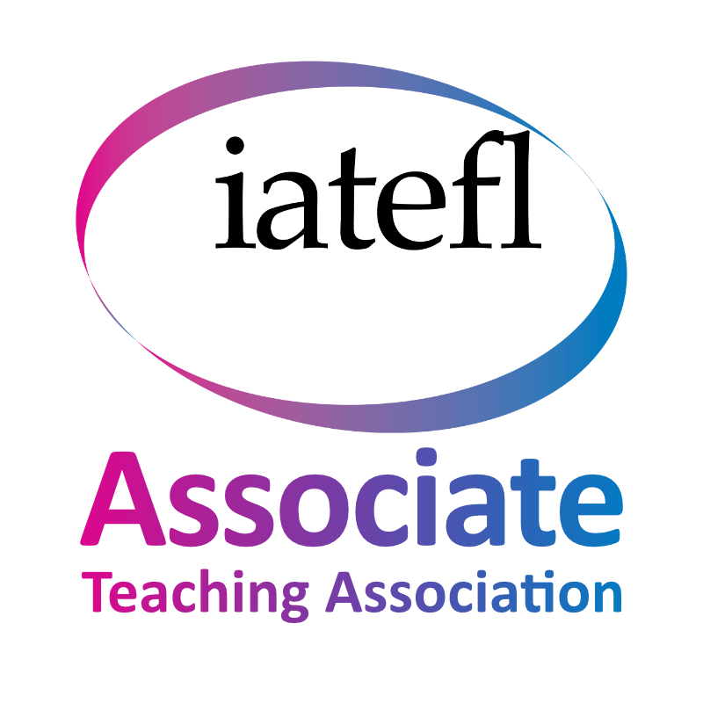
NATESOL Annual Conference 2026 Call for Proposals
Submission deadline: 23rd April 2026

NATESOL’s 42nd Annual Conference - Technology for 21st Century English Language Learning and Teaching

Saturday 16th May 2026
Hybrid (Online via Zoom and at Manchester Metropolitan University)

Plenary Speaker - Professor Phil Hubbard, Stanford University USA (Integrating Generative AI into Second Language Listening: Explorations in Professional Development)

Professor Phil Hubbard, PhD, is Senior Lecturer Emeritus in the Stanford University Language Center. Working in the field of computer-assisted language learning (CALL) since the early 1980s, he has published in the areas of CALL theory, research, methodology, evaluation, teacher education, learner training, and listening. He served on the task force that developed the TESOL Technology Standards and is associate editor of Computer Assisted Language Learning and Language Learning & Technology. His recent work focuses on CALL theory, technology standards for language teaching, and guidelines for using generative AI efficiently, effectively and ethically.

For the last 42 years, throughout the many turning points and developments of language teaching and learning and technology, NATESOL has observed and reported on new developments. So, technology in Language Teaching is certainly not a new topic, but the recent pace of change and introductions of new advancements is unprecedented. Many teachers and learners around the world are embracing Artificial Intelligence to make their lives easier ad improve outcomes, but with these new affordances, how do we know which are the best, or which types of affordance include essential ingredients for success? Along with Generative AI to help learners individualise their learning through the use of chatbots and apps to check their written output, teachers are using AI to create texts, images and associated materials and to check students’ work. Vibe coding is now available to teachers so that they can create apps that create materials for specific contexxts, mark students’ work using specific marking criteria and more. Of course technology is not limited to AI; teachers continue to work online with a range of software and continue to use Virtual Learning Environments. NATESOL is seeking conference proposals on all technological innovations from which other teacher can learn best practice. Therefore, for our 42nd annual conference, we invite speakers who have fostered or investigated innovative and practical approaches to using technology to help our learners develop, to share their practice so that other teachers may benefit their learners by implementing these ideas.

In a world where our professional lives are so busy, this event will be online and face-to-face, so we welcome speakers from across the globe and across the field of English language teaching including ESOL, EAL / ELL, EFL and EAP.

Key themes
We welcome presentations, workshops or posters (see below) which are based on scholarly investigation and/or provide tips for practicing teachers in the following broad themes: evaluations and/or recommendations for the use of technology…
- … for online language teaching and learning
- … to lighten teacher duties (including, but not limited to, materials development and marking)
- … to help with Learner autonomy and self-regulated learning through independent study
- … to individualise the learning process for mixed ability classes
- … for SEN students
- … for motivating students
- … for learners' self-assessment
- … to facilitate interaction between learners
- … to facilitate understanding of language systems
- … for teacher training
- … for identifying learners’ needs
and
- Ecological and sustainable uses of technology for learning and teaching

What to expect
The 2026 NATESOL conference provides an opportunity to share practice and meet fellow teachers in a friendly and open atmosphere. We also offer a range of mentoring for first-time speakers or for those who might feel unfamiliar with the online platforms.

Formats for contributions

Live presentations
- Either 30 or 15 minutes long.
- For anyone wanting to share practice / research findings.
- We offer mentoring for first-time presenters.
- Please note, this is not a space for planned research or research in process (see Posters).

Pre-recorded presentations
- 15 minutes long.
- For anyone wanting to share practice/research findings.
- The recording will need to be shared with conference organisers before the event.
- The presenter will need to be available to participate in simultaneous chat discussions during the session.
- We offer mentoring for first-time presenters.
- Please note, this is not a space for planned research or research in process (see Posters).

Live workshops
- 45 minutes.
- For anyone who wants to interactively share and demonstrate their practice.
- We offer mentoring for anyone who may be unfamiliar with leading online workshops.
- Please note, this is not a space for planned research or research in process (see Posters).

Posters
- For anyone who is planning or in the process of conducting research.
- Posters will be shared on an interactive platform.
- We offer mentoring for anyone who needs support when designing an online poster.
- The researcher will need to be available to answer questions using a microphone and chat during the conference.

Submission:
- Please submit your proposal by the end of the day on 23rd April 2026
- Submit your proposal by completing the online form at this link: https://forms.gle/BAbYbKybpvPfDnBs9
- If you have any questions or problems with your submission, please email natesolcommittee@gmail.com and one of our volunteers will get back to you.

Conference fees:
- Speakers free; Members £10; non-members £15; Unwaged & students £5. (NATESOL is a not-for-profit organisation. This year, we are keeping our fees as low as possible due to the current economic climate). A percentage of the conference ticket sales will be donated to helping trainee teachers to gain experience through placements. Certificates of attendance will be available for all upon completion of the feedback form. Registrations open via our website NATESOL.org on 27th March.

