Not Again? Charlie Hadfield
The horror of war:
each generation forgets
what their parents learned.

Children of War. Jill Hadfield

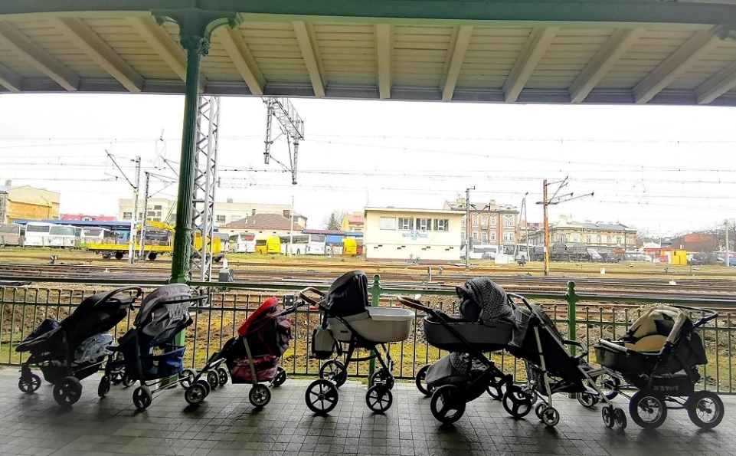

Outside the Polish station
A line of empty pushchairs
Waiting to be filled.

At the bombed-out hospital
All the waiting pushchairs
That never will be filled.

